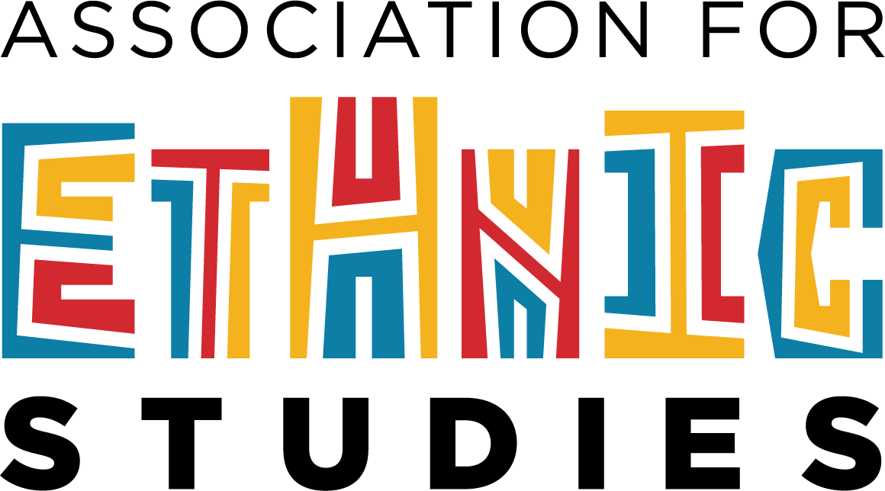

Ethical Community Care: Imagining New Futures While Living in the Now
Annual Conference
November 4-6, 2022
California State University-LA

“To build community requires vigilant awareness of the work we must continually do to undermine all the socialization that leads us to behave in ways that perpetuate domination.” ~ bell hooks

2022 marks the 50th anniversary of the Association for Ethnic Studies. In 2021 bell hooks became an ancestor. The central overlap between the AES and critical scholar bell hooks is the care of the community. At our annual conference, we will take up the larger question: how do we engage in the ethical care of our communities?

The attacks against Ethnic Studies, Critical Race Studies, policing that continues to harm our communities, white terrorism, pandemics, and racism among other forms of domination cause us to think about how we engage in the work necessary to undermine the socialization that perpetuates and supports domination. Domination, both within and beyond the United States, continually reveals much about the underlying dynamics of culture and society. And yet, those on the margins of society continue to engage in activism and undertake ethical care of their communities. What is ethical care? How has ethical community care changed in the era of social media?

We invite proposals for papers and panels on all topics related to ethnic studies and community/communal care, justice, and freedom. Topics may include but are not limited to:
Ancestral knowledge
Capitalism
Collective memories of care
Critical race theory
Education
Environmental activism/care
Global racism
Immigration
Institutions
Inter and Intragroup contestation of solidarity
Land—displacement, gentrification, removal, sense of place
Policing
Radical empathy
Science
Settler Colonialism/Colonialism
Social movements
The state
Threats to Democracy
White terrorism/rage/protectionism

Submit proposals for papers and or panels by August 30, 2022
Papers should be submitted to: (email) naes@ethnicstudies.org. Subject line: 2022 Annual Conference Proposal_your name.

